**Experiment No: 3**

**Interfacing External LED and Buzzer**

Name of the Student: ____________________ _______ Div. & Roll No.______

**Aim**: To interface external LED and Buzzer to Node MCU

**Components Required:**

1. Node MCU – 1
2. Micro USB Cable – 1
3. PC/Laptop – 1
4. Connecting Wires
5. Bread Board – 1
6. LED – 4
7. Buzzer -1
8. Resistor 200 Ohm – 1

**Software Required:**

Arduino IDE

Theory:

We are familiar with blinking [LED using Arduino boards](https://microcontrollerslab.com/led-blinking-arduino-uno-r3/) as this is the fundamental step towards using a new development board. In this experiment, first we will see how to connect an external LED with**Node MCU** and how to**blink it using GPIO pins** of ESP8266 Node MCU. After that we will see how to connect buzzer with Node MCU.

**Procedure:**

1. **Blinking External LED**

Step 1: Make the circuit diagram on bread board according to connection diagram shown below. Anode of the LED [long leg of the LED] is connected to the D1 pin of the Node MCU, the cathode of the LED [short leg of the LED] is connected with the one terminal of the resistor [200 Ohm] and another terminal of the resistor is connected to the ground pin.

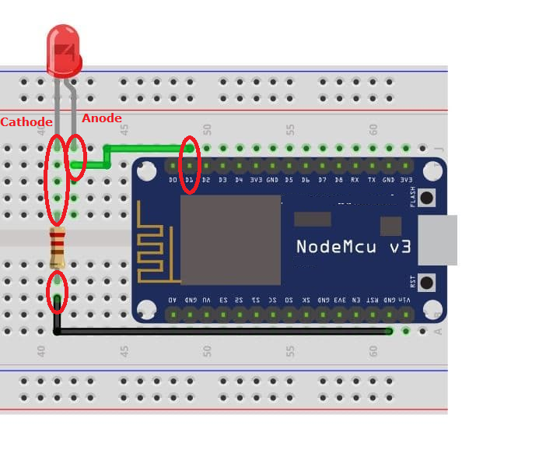

Step 2: Connect Node MCU to PC / Laptop with the help of micro USB cable

Step 3: Open new Sketch, Go to file ----> New

Step 4: Write following code in new sketch

// the setup function runs once when you press reset or power the board

void setup() {

pinMode(D1, OUTPUT); // initialize digital pin LED_BUILTIN as an output.

}

// the loop function runs over and over again forever

void loop() {

digitalWrite(D1, HIGH); // turn the LED on (HIGH is the voltage level)

delay(1000); // wait for a second

digitalWrite(D1, LOW); // turn the LED off by making the voltage LOW

delay(1000); // wait for a second

}

Step 5: Save the new sketch by appropriate name in a folder on your PC / Laptop

Step 6: Upload the sketch on Node MCU. Go to Sketch ----> Upload

Step 7: Observe the output [Blinking External LED]

1. **Connecting Buzzer**

Step 1: Make the circuit diagram on bread board according to connection diagram shown below. Positive terminal of buzzer [long leg of the buzzer] is connected to the D5 pin of the Node MCU, negative terminal of buzzer [short leg of the buzzer] is connected to the ground pin.

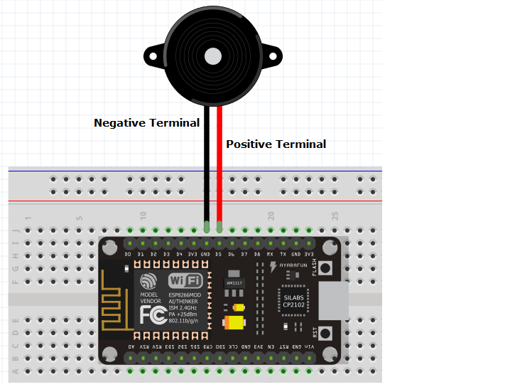

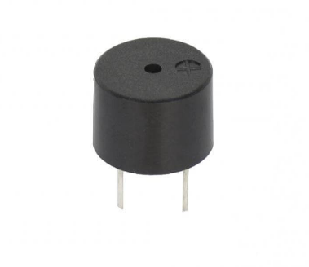

Step 2: Connect Node MCU to PC / Laptop with the help of micro USB cable

Step 3: Open new Sketch, Go to file ----> New

Step 4: Write following code in new sketch

void setup()  
{  
 }  
void [loop](https://elearn.ellak.gr/mod/glossary/showentry.php?eid=264&displayformat=dictionary)()  
{  
    tone(14, 494, 500);   
    delay(1000);  
}

The three numbers inside the tone() function represent: the pin we send the sound (D5 or 14 in our case), the frequency of the sound wave we send and the duration of the tone.  
You can change the last two parameters and play with the speed of the beeps and the sound of them.

Step 5: Save the new sketch by appropriate name in a folder on your PC / Laptop

Step 6: Upload the sketch on Node MCU. Go to Sketch ----> Upload

Step 7: Observe the output

**Practice:**

1. Connect 2/3/4 External LEDs and try different patterns of dancing LEDs
2. In tone function, use different music notes with different time period and run the melody.

**Conclusion:**

**________________________________________________________________________________________________________________________________________________________________________________________________________________________________________________________________________________________________________________________**